WORLD ASTHMA DAY CELEBERATION -2023

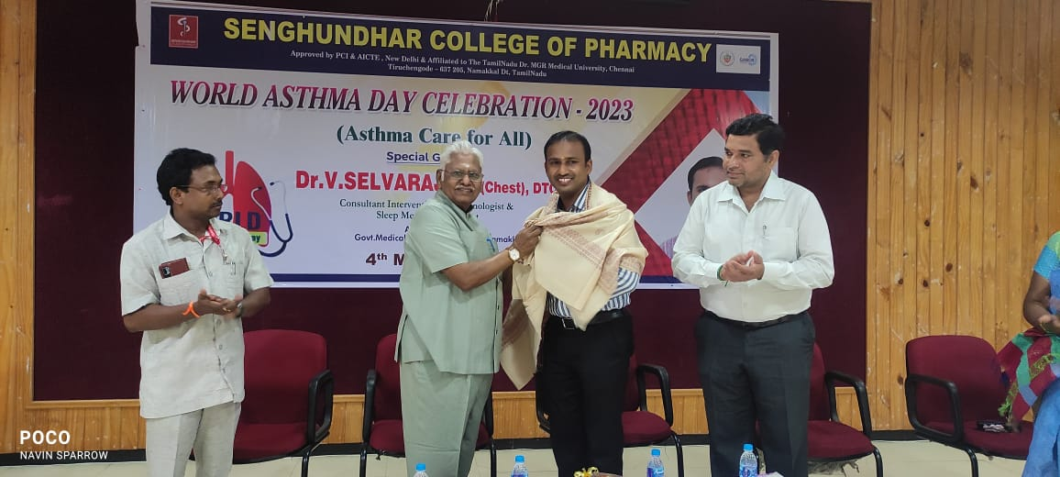

NATIONAL TECHNOLOGY DAY CELEBERATION 2023

